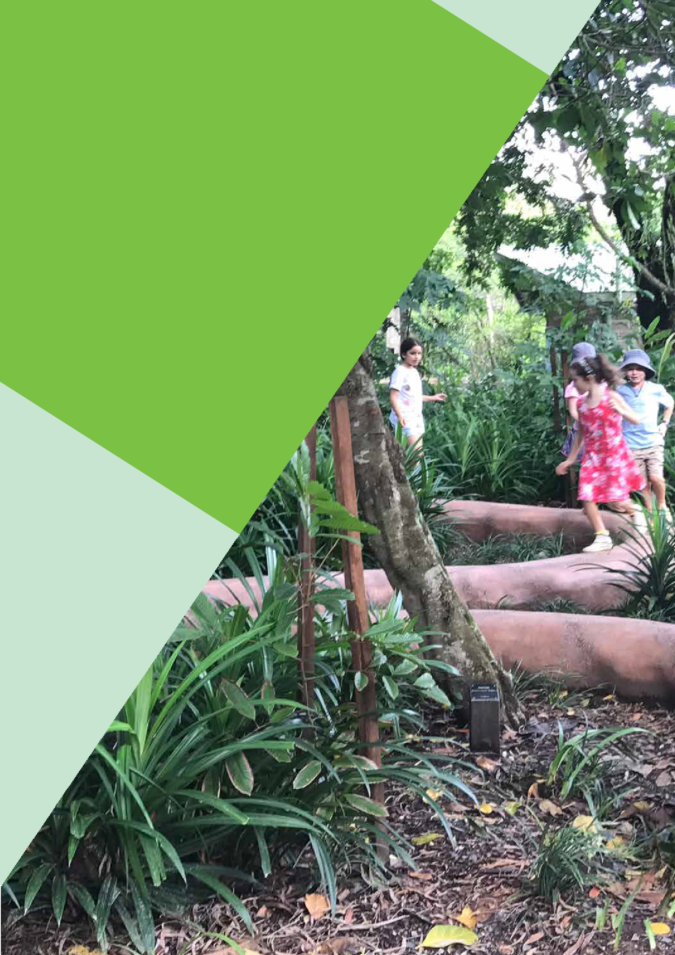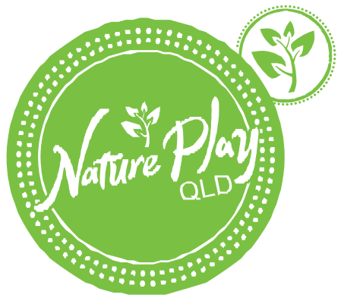Nature Play Spaces

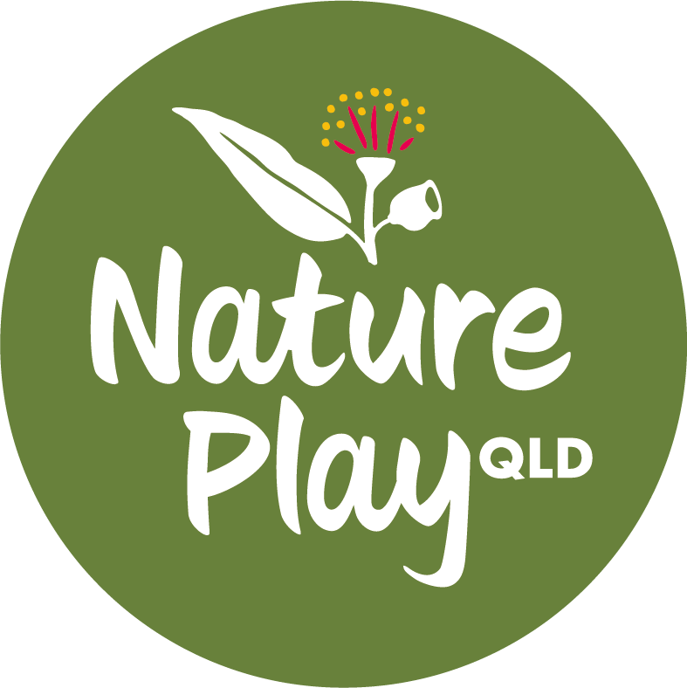
Project Plan

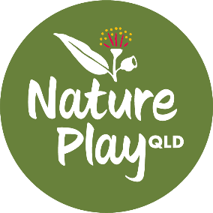

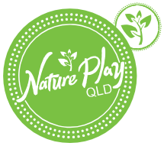Project Name:

Nature Play Spaces - Project Plan
Project Lead/ Coordinator/ Champion:
- Project Vision Statement The purpose of this project is to:
- Background The following information provides background information to this project:
- Project Objectives The project aims to:
- Stakeholders May include:
- Teachers
- Students
- Parents
- P&C / P&F / Board
- School Grounds Staff
- Outside School Hours Care Service – staff and children
- Organisational Requirements It is proposed that following resources would be required:
- Approach The project will be approached along the following lines:

Objective  (delete anything not relevant to the  project) | Possible Actions and Ideas (delete anything not relevant, add new actions and ideas)
Plan of proposed area  To have an accurate plan of the area to be developed | - Obtain a survey or drawing of the area OR  - Determine the project boundaries  - Determine the whole project area  - Map existing features onto a plan or mud map  - Identify different zones for planning across the school – give each one a name or identifier
Auditing  To determine what is already onsite (above and below ground), what should be kept, what should be removed, what should be replaced, what areas need to be clean up | Items to audit  - Trees, vegetation  - Playground equipment / features – fixed  - Underground /on ground /above ground services  - Shade structures  - Furniture (fixed)  - Fences, paths, garden beds  - Refer to an asset plan if you have one  - Natural materials for recycling (and a place for storage)  - Natural features (creek or drainage line)

Site Establishment | - Once project boundaries have been established clean up the site and then continue with the play space development with the newly cleared space  - Ensure the site is safe and secure before, during and after site clearing  - Engage arborists to correctly prune trees to maximise safety, retain some shade benefit and provide the necessary space for the new design
Nature Play Research  To find out what is possible and what is being done elsewhere with success and increase awareness of what is nature play and outdoor learning in a school environ- ment and could be and the benefits to all children by increasing their access to nature | - Make of list of play and leaning experiences that could be incorporated into the spaces and do some research  - Make of list of places to visit and go and take photos, notes etc  - Build a model (time permitting)  - Ensure low levels of duplication of play experiences with the rest of the schools’ outdoor facilities  - Determine what natural features are unique to the area for incorporation in the design (rocks, trees, plants that will thrive, known native animals that pass through)  - Make a list of the play opportunities that are essential to the project and must be included in the final design
Early concept drawings and photos | - Draw some mud maps of your early ideas so you have something to share with your supporters and future supporters.
Supporters and Sponsors  To have a group of supporters for the new playground within the educators, parents, friends, community and local businesses and bring as many people on the jour- ney of creating a wonderful new play space | - Bring the Teachers and Parents on board with ideas  - Find willing helpers and parents and friends with  skills (trade, landscape architecture, building, drawing, designing etc)  - Send letters to local groups who could support with in-kind or financial sponsorship  - Determine which local businesses could get involved and invite them to a “nature activity”  - Develop a reference or support group to help give the Project Lead support and encouragement and help keep the project on track
Community Engagement  To bring everyone along on the journey of designing a new playground for the kindy and for them to feel part of the process and in particular to stay up to date with decisions and activities | - Develop a community engagement plan for the whole project (NPS can help out here)  - Actions might include:  - Loose Parts Play Day  - Family activity days  - Facebook page  - Discussion meetings  - Design workshop  - A parent reference group  - A newsletter  - Group site visit
Project and Design Principles  To have an agreed set of principles that can be followed when developing your design and construction plans | - Discuss with Parents, Teachers and Students what is important (what people value) about nature play and outdoor learning and what needs protecting and advocacy (e.g. mud play is good, students can get wet while playing and learning etc)

- From the things that people value, develop a set of principles and a methodology that you will stick to while you are designing and developing the spaces
- NPQ Spaces can help facilitate these discussions with developing nature play spaces and outdoor class rooms, and child lead play and curriculum spaces
- Prepare Risk Benefit Assessments if any of the play features appear to be risky or challenging
Concept Design  To create a concept design of the play space taking into consideration your design principles and existing features | - Utilise community engagement + initial site visits/ audits for early concept sketching  - Work out staging (if necessary) at this point  - Using the agreed principles and design methodology commence working out how you want to improve  the play spaces and outdoor classroom areas through a design and with site modification  - Involve the School Ground Staff to help realise your ideas onto paper or  - Do a design yourself with your own teachers and volunteers or  - Contact a bespoke nature play space designer and ask for a design and quote  - Share the ideas and design with all your supporters and move to finalising the design into a master plan and developing a budget and works program (stages, costs)  - Talk to a playground certifier if needed during the design process
Resources (In-kind and Financial)  To fund-raise, source materials and find volunteers to build the new play features including and nature play spaces | - Work out a budget for the various play features and site modifications  - Hold fund raising activities  - Source materials from the community – recycled, product donations  - Source play items from suppliers or hardware stores  - Chase sponsorships and grants  - Enlist and support volunteers and in-kind supporters
Approvals  To gain approval of the agreed plan from management | - Present the final plan to key stake holders for agreement and support  - Present the final plan to the relevant managers or  governing bodies for approval  - If necessary, discuss plans with playground certifiers for approval under the Australian Playground Standards
Construction  To construct or create the play elements outlined in the design | - Identify which aspects of the project need design documentation, engineering certification and risk benefit assessments and undertaken (if any)  - Tender and contracting aspect of the design construction - using contractors when necessary  - Use volunteers when available and appropriate  - Undertaking the project in stages is fine but work out what the stages will be early in the process  - If needed, have play space certified  - Update insurance and asset management data
Communication and Celebrate small wins  To have communication tools to spread the message and share information and resources | - Be ready to share the experience  - Take lots of photos / video  - Get the children, educators and parents talking and sharing experiences

Deliverables and Timeframes

Short Term Actions
  - Consult with Nature Play QLD (commenced on x/x/xx), ideas and discussion summary o Ideas
o Discussion points Medium Term
Long Term

Critical Success Factors (examples only)
  - Completion of the project (as a whole or in stages) to the satisfaction of the key stakeholders, students and parents
- The children really engage with the play space and the benefit nature play is enjoyed by all

Risks (examples only)
- Constraining the space and play and learning values by not providing adequate flow and movement around and through the new play space
- Undertaking works on the ground in an ad hoc manner without an overall plan
- Budget constraints
- Managing storm water
- Tree limb management

Resources
Add any relevant web links and contacts in here
  - Places to go and visit
  - Website to look up
  - People to talk to about taking the project to the next stage
  - Training and programs

Document Control

Version # | Change Description | Date | Author
V1 | 1st Draft

