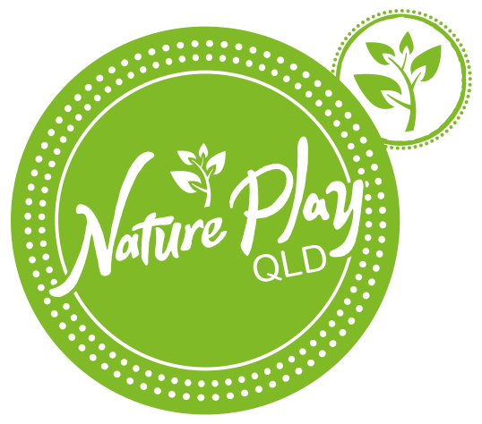
Nature Play Blog post guide
For general blog submissions

Please return the following in word:

- TITLE of your blog post:

- Your name & organisation/school:

- Location (in QLD):

- Email address (internal use only):

- Do you wish to remain anonymous?

- Short summary or ‘teaser’ for blog homepage (100 words):

- Captions for all photos, or links to YouTube etc:
- Photo 1:
- Photo 2:

- Blog content (usually approx. 700-1000 words in a non-formatted word document).

- We support you to promote yourself or your organisation with your organisation blurb or bio (100 words) at the end of your blog, if you wish.

Other tips:

- We recommend providing at least one photo to support your blog post (please ensure you have suitable approval to use the photo, particularly those of children).

- If you’d like images inserted at specific places, please simply request with words at the desired place eg - [insert image124.jpg here]

- We encourage you to use links to strengthen your content, where practical. To do so in a way that will help us with formatting, please write the url next to your desired word. Eg, [Nature Play QLD www.natureplayqld.org.au] promotes outdoor play.

- Please submit your blog to Nature Play QLD Social Media Coordinator at social@natureplayqld.org.au in a word document with photos attached as .JPG files

Thanks for your contribution!

